**QUESTION:**

<https://gist.github.com/rvsp/51ac78f183db0cebde984fd45b90b2a8>

|  |
| --- |
| The Following are the tables has to be in your database & model deisgn: |
|  | users |
|  | codekata |
|  | attendance |
|  | topics |
|  | tasks |
|  | company_drives |
|  | mentors |
|  | students_activated_courses |
|  | courses |
|  |  |
|  | The following are the queries need to be executed |
|  |  |
|  | 1. **Create tables for the above list given** 2. **insert at least 5 rows of values in each table** |

**ANSWER:**

**create table users (id integer(40), name varchar(50), batch varchar(40));**

insert into users values (1,"Ashish","B27WD");

insert into users values (2,"Preetha","B26WD");

insert into users values (3,"Zen","B28WE");

insert into users values (4,"Neetha","B29WD");

insert into users values (5,"Chris","B27WE");

insert into users values (6,"Nashil","B29WE");

insert into users values (7,"Rashi","B29WD");

**create table codekata (username varchar(50),problems_solved integer(40));**

insert into codekata values ("Preetha",30);

insert into codekata values ("Ashish",20);

insert into codekata values ("Chris",50);

insert into codekata values ("Nashil",48);

insert into codekata values ("Neetha",62);

insert into codekata values ("Rashi",57);

insert into codekata values ("Zen",44);

**create table attendance (username varchar(50), attendance_percentage integer(30));**

insert into attendance values ("Preetha",89);

insert into attendance values ("Zen",100);

insert into attendance values ("Ashish",93);

insert into attendance values ("Rashi",67);

insert into attendance values ("Chris",53);

insert into attendance values ("Neetha",100);

insert into attendance values ("Nashil",100);

**create table topics (topic_name varchar(100),problems_in_topic integer(50));**

insert into topics values ("js-numbers",25);

insert into topics values ("js-array",30);

insert into topics values ("js-string",50);

insert into topics values ("js-advanced",40);

insert into topics values ("html-basic",100);

insert into topics values ("html-advanced",80);

**create table tasks (task_name varchar(60),task_category varchar(60) ,task_description varchar(200));**

insert into tasks values ("Read and analyze","Introduction","Perform tasks in https://docs.google.com/document/d/1QznT1zM4mI6dG0TODx5Xjs1GquMoSHO3xZ1USDnVM-w/edit?usp=sharing");

insert into tasks values ("Practise","JS","Practise problems in codekata");

insert into tasks values ("tags","Html","all input elements in html");

insert into tasks values ("design webpage","CSS","Create a advertisement poster");

insert into tasks values ("API","react","Perform all CRUD operations and use mockAPI");

**create table company_drives (company_name varchar(100),student_name varchar(100));**

insert into company_drives values ("RazorPay","Ashish");

insert into company_drives values ("Paypal","Ashish");

insert into company_drives values ("RazorPay","Chris");

insert into company_drives values ("RazorPay","Neetha");

insert into company_drives values ("Paypal","Preetha");

insert into company_drives values ("zoho","Ashish");

insert into company_drives values ("zoho","Rashi");

insert into company_drives values ("zoho","Neetha");

insert into company_drives values ("zoho","Nashil");

**create table mentors (mentor_name varchar(100),student varchar(100));**

insert into mentors values("lavanya","Preetha");

insert into mentors values("lavanya","Zen");

insert into mentors values ("lavanya","Ashish");

insert into mentors values ("Ash","Rashi");

insert into mentors values ("Akshay","Chris");

**create table students_activated_courses (studentname varchar(100), coursename varchar(100));**

insert into students_activated_courses values ("Ashish","HTML");

insert into students_activated_courses values ("Chris","Python");

insert into students_activated_courses values ("Preetha","Full stack developmet");

insert into students_activated_courses values ("Neetha","Python");

insert into students_activated_courses values ("Zen","HTML");

**create table courses (course_id integer(50),course_name varchar(100));**

insert into courses values (1,"Full stack development");

insert into courses values (2,"HTML");

insert into courses values (3,"python");

insert into courses values (4,"ML");

insert into courses values (2,"Blockchain");

1. get number problems solved in codekata by combining the users

**ANSWER:**

**select sum(problems_solved) as total_of_solved_problems from codekata;**

**OUTPUT:**

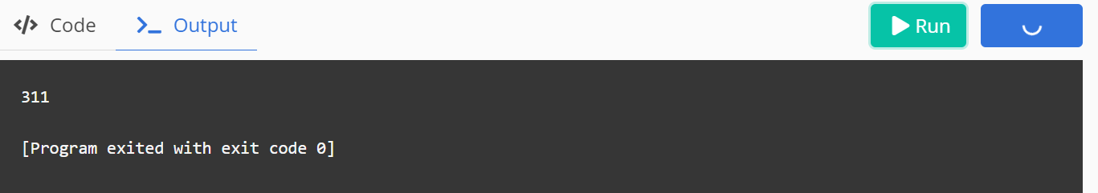

|  |
| --- |
|  |
|  | 1. display the no of company drives attended by a user   **ANSWER:**  **select count(company_name),student_name from company_drives group by student_name;**  **OUTPUT:** |
|  | 5. combine and display students_activated_courses and courses for a specific user groping them based on the course  **ANSWER:**  **select studentname, coursename, course_id from students_activated_courses left join courses where course_name=coursename;**  **OUTPUT:** |
|  | 6. list all the mentors  **ANSWER:**  **select distinct mentor_name from mentors;**  **OUTPUT:** |
|  | 7. list the number of students that are assigned for a mentor  **ANSWER:**  **select count(mentor_name),mentor_name from mentors group by mentor_name;**  **OUTPUT:** |